**Chapter 1**

**INTRODUCTION**

C

hatbots, or conversational interfaces as they are also known, present a new way for individuals to interact with computer systems. Traditionally, to get a question answered by a software program involved using a search engine, or filling out a form. A chatbot allows a user to simply ask questions in the same manner that they would address a human. The most well-known chatbots currently are voice chatbots: Alexa and Siri. However, chatbots are currently being adopted at a high rate on computer chat platforms. The technology at the core of the rise of the chatbot. Recent advances in machine learning have greatly improved the accuracy and effectiveness of natural language processing, making chatbots a viable option for many organizations. A simple chatbot can be created by loading an FAQ (frequently asked questions) into chatbot software. The functionality of the chatbot can be improved by integrating it into the organization’s enterprise software, allowing more personal questions to be answered, like “What is my balance?”, or “What is the status of my order?”. Most commercial chatbots are dependent on platforms created by the technology giants for their natural language processing. These include Amazon Lex, Microsoft Cognitive Services, Google Cloud Natural Language API, Facebook Deep Text, and IBM Watson. Platforms where chatbots are deployed include Facebook Messenger, Skype, and Slack, among many others.

**Chapter 2**

**Literature Survey**

Now a day people tend to seek knowledge or information from internet that concern with health through online healthcare services. The basic aim of this system is to bridge the vocabulary gap between the health providers by proving instant replies to the questions.

Chart Bot [1] A chatbot is a computer program designed to simulate human conversation. These chatbots reply to you instantly according to your queries because programmers have inserted thousands of inputs/replies/queries into the database that can be asked by the user. To make an advanced chatbot we've to code more and more but I tried to make a simple chatbot with few lines of codes and queries which help you to get an idea about how chatbot actually works.

Chart Bot [2] Chatbot technology has hit the market recently. This new piece of software enabled brands with a very intuitive way to communicate with their customers — conversation. This triggered a range of new ideas coming to creative minds.

Chart Bot [3] To perfectly simulate a human dialogue, the bot must analyze the input given by the user correctly and formulate a response that should be relevant and appropriate. The Chabot was realized as a website application based on search engines, custom learning, custom cascading style sheets and JavaScript for making conversations as real as possible.

Chart Bot [4] Speech and textual information play a crucial role in communicating between humans. An article in “The New York Times” published that now-a-days the adults are spending more than 8 hours a day on screens of computers or mobiles. So the major communication between humans is conducted through web applications such as WhatsApp, Facebook, and Twitter etc as a form of speech and textual conversation. In the present paper, we have focused on designing a textual communication application namely chatbot in the educational domain. The proposed chatbot assists in answering questions provided by the users. To develop the system, we have employed an ensemble learning method as random forest in the presence of extracted features from our prepared dataset. Besides, the validation system offers an average F-measure 0.870 score on various K-values under random forest for the proposed chatbot. Finally, we have deployed the proposed system in a form of telegram bot.

**Chapter 3**

**Problem Statement and Proposed Solution**

A

n activity aimed at identifying a problem by specifying the undesirable and problematic state currently occupied, the resources currently available to move away from that problematic state, particularly the available courses of actions, the combinatorial [constraints](http://pespmc1.vub.ac.be/ASC/CONSTRAINT.html) on using them, etc., and the criteria that need to be satisfied to say that a problem no longer exists or is solved. This activity defines the cognitive gap between what is and what is desirable and delineates the resources for closing it. Problem formulation is the creative and probably the more important step towards overcoming a problematic state than [problem-solving](http://pespmc1.vub.ac.be/ASC/PROBLEM-SOL.html).

**3.1 General**

Cyberspace is a gigantic community of millions, where people reach for schools, learn about movies, shops, listen to music, watch video games, make business transactions like buying and selling of stocks and shares e-commerce. Many also develop sites of their own. People buy tickets through the internet, draw money from the banks through A.T.M., buy through credit cards, send information to friends and relations through e-mails and do hosts of other business. Thus, the use of computers and the internet are rapidly increasing at every corner of the world. This is evident from the mushrooming of Cyber Cafes in various cities, towns, even semi towns. So, this is called an **“Age of computers”.** Because of the use of computers today, people can be reached faster, jobs and works can be done quickly in a shorter time and with fewer hands. Manual labour is reduced to the minimum with the use of computers. Due to global connectivity, numerous changes and developments are seen in all spheres of human life. The internet has opened up a world of information for anyone with a computer and a connection. Businessmen and consumers are increasingly using computers to create, transmit and store information in the electronic form instead of traditional paper documents and files. Information stored in electronic form has many advantages. It is cheaper, takes very less space and hence easier to store, retrieved and speedily communicated through electronic mail (e-mail). International business and trade through e-commerce are growing very fast during the last 12-15 years and many advanced countries like U.S.A., U.K., Germany, Japan, Canada, Australia have switched over from traditional paper-based business to electronic business.

Nowadays more and more correspondences are made through e-mail than through the post. It is also quick and less expensive. In spite of the several uses of computer and internet, there are some disadvantages and negative implications such as online addiction, cyber disorders, stressful lifestyle and Cyber Crimes. These adverse effects of Cyber World on the users of internets are evident from several studies and observations. Today cybersecurity has become very important and the necessity of disciplinary regulation of Cyber Cafe and other internet service providers has become imperative. As more and more companies connect their networks to the internet, awareness of computer crimes (Cyber Crimes) becomes critical.

**3.2 Problem Statement**

**Cybercrime involves a number of issues ranging from the theft of information from a computer system or network to the use of a computer as a tool during the commission of a crime.** Virus attacks target the security of network health and should be coordinated with other security efforts. Even after taking several measures to avoid computer crime and protect computers, still, computer crimes do occur at some point or other. Cyber Crime in simple terms refers to possible misuse arising out of transactions and other dealings concluded over the electronic medium and criminal liability for the contravention of the provisions of the proposed legislation. Therefore, the highest priority should be given to prevention.

**3.3 Aim of the work**

The problem of cybercrime has reached such a dimension that it needs systematic investigation so that computer crimes can be prevented. If any incidents are committed over the internet and if a society is suffering from it then it should be regulated. An authorized body should handle all such crimes. This work aims at creating a web interface for the people to register complaints and an authorized body to take actions.

**3.4 Objectives**

Based on the study about cybercrimes and its security and prevention, this work is designed in such a way that it should respond to, resolve, and recover from cyber incidents and attacks through timely information sharing, collaboration, and action.

**Chapter 4**

**Requirement Specification**

R

equirements specification is a specification of software requirements and hardware requirements required to do the project. Requirements analysis encompasses those tasks that go into determining the needs or conditions to meet for a new or altered product or project, taking account of the possibly conflicting requirements of the various stakeholders, analyzing, documenting, validating and managing software or system requirements.

**4.1 Hardware Requirements**

|  |  |  |
| --- | --- | --- |
| **Sl. No** | **Hardware / Equipment** | **Specification** |
| **1.** | **Processor** | **Intel i5 Core Processor** |
| **2.** | **Clock speed** | **2.20GHz** |
| **3.** | **Monitor** | **1024*768 Resolution, Color** |
| **4.** | **RAM** | **8GB** |

**4.2 Software Requirements**

|  |  |  |
| --- | --- | --- |
| **Sl. No** | **Software** | **Specification** |
| **1.** | **Web Browser** | **Google Chrome** |
| **2.** | **Operating System** | **Windows 10** |
| **3.** | **Scripting** | **HTML5, CSS3, PHP, JavaScript, Bootstrap, jQuery, Angular** |
| **4.** | **Database** | **MySQL** |
| **5.** | **Tool used** | **XAMPP Server** |

A web browser, or simply "browser," is an application used to access and view websites. Common web browsers include Microsoft Internet Explorer, Google Chrome, Mozilla Firefox, and Apple Safari. The primary function of a web browser is to render HTML, the code used to design or "mark up" webpages. Each time a browser loads a web page, it processes the HTML, which may include text, links, and references to images and other items, such as cascading style sheets and JavaScript functions. The browser processes these items, then renders them in the browser window.

An operating system is a software which acts as an interface between the end user and computer hardware. Every computer must have at least one OS to run other programs. An application like Chrome, MS Word, Games, etc. needs some environment in which it will run and perform its task. The OS helps user to communicate with the computer without knowing how to speak the computer's language. It is **not** possible for the user to use any computer or mobile device without having an operating system.

A script or scripting language is a computer language with a series of [commands](https://www.computerhope.com/jargon/c/command.htm) within a file that is capable of being executed without being [compiled](https://www.computerhope.com/jargon/c/compile.htm). Good examples of [server-side scripting](https://www.computerhope.com/jargon/s/server-side-scripting.htm) languages include [Perl](https://www.computerhope.com/jargon/p/perl.htm), [PHP](https://www.computerhope.com/jargon/p/php.htm), and [Python](https://www.computerhope.com/jargon/p/python.htm). In this project PHP is used for web application development. The best example of a client side scripting language is [JavaScript](https://www.computerhope.com/jargon/j/javascript.htm). A full list of scripting languages and other programming languages can be found through our [programming language](https://www.computerhope.com/jargon/p/programming-language.htm) definition. In this project CSS, html, JavaScript are used for client side programing.

MySQL is the world’s most popular open source database. With its proven performance, reliability, and ease-of-use, MySQL has become the leading database choice for web-based applications, used by high profile web properties including Facebook, Twitter, YouTube, and all five of the top five websites. In this MySQL is used for data storage.

XAMPP is a [free and open-source](https://en.wikipedia.org/wiki/Free_and_open-source) [cross-platform](https://en.wikipedia.org/wiki/Cross-platform) [web server](https://en.wikipedia.org/wiki/Web_server) [solution stack](https://en.wikipedia.org/wiki/Solution_stack) package developed by Apache Friends, consisting mainly of the [Apache HTTP Server](https://en.wikipedia.org/wiki/Apache_HTTP_Server), [MariaDB](https://en.wikipedia.org/wiki/MariaDB) [database](https://en.wikipedia.org/wiki/Database), and [interpreters](https://en.wikipedia.org/wiki/Interpreter_(computing)) for scripts written in the [PHP](https://en.wikipedia.org/wiki/PHP) and [Perl](https://en.wikipedia.org/wiki/Perl) [programming languages](https://en.wikipedia.org/wiki/Programming_language). Since most actual web server deployments use the same components as XAMPP, it makes transitioning from a local test server to a live server possible.

**Chapter 5**

**Analysis and Design**

P

roject design is an early phase of the project where a project's key features, structure, criteria for success, and major deliverables are all planned out. A functional approach is most likely to be successful when the amount system stated information is minimized and information sharing is explicit. So, the implementation technique used is more efficient and compact.

**5.1 Analysis**

There is a need for online registration of complaints and e-filing of FIRs. This reduces both plaintiff as well as the cybercrime security official. Victims of cybercrime can register their complaint online anywhere and anytime by providing necessary details like date and time of incident, type of crime, etc. After successful registration, its status can be tracked by the user anytime. On the other hand, after receiving the complaint from plaintiff cyber security officer can file FIR. The filed cases automatically change status of complaint at plaintiff module. Once this is achieved further process can be easily done reducing time constraint.

**5.2 Design**

The system that is designed is as per the analysis of requirements. To implement such a system web technology is one of the platforms. This project is developed using some web technologies. Microsoft Visual Studio Code which is an integrated development environment (IDE) used in web development is used in its development. This project is designed to have two modules basically: Plaintiff module and Cybercrime Supervisory module. A plaintiff is a person who is giving a complaint and the supervisory module is used by the authorized Cybercrime security official. A plaintiff can register a complaint with all the necessary information. Once the complaint is registered the system will generate a unique identification number (ID). This ID is a reference to that plaintiff for the future. An official can use the supervisory module after successful login using a valid username and a password. An authorized official can check all the registered complaints, file a complaint or close a case. All this information is stored and fetched to/from respective files.

**5.2.1 Data Flow Diagram**

A data flow diagram (DFD) maps out the flow of information for any process or system. It uses defined symbols like rectangles, circles and arrows, plus short text labels, to show data inputs, outputs, storage points and the routes between each destination.

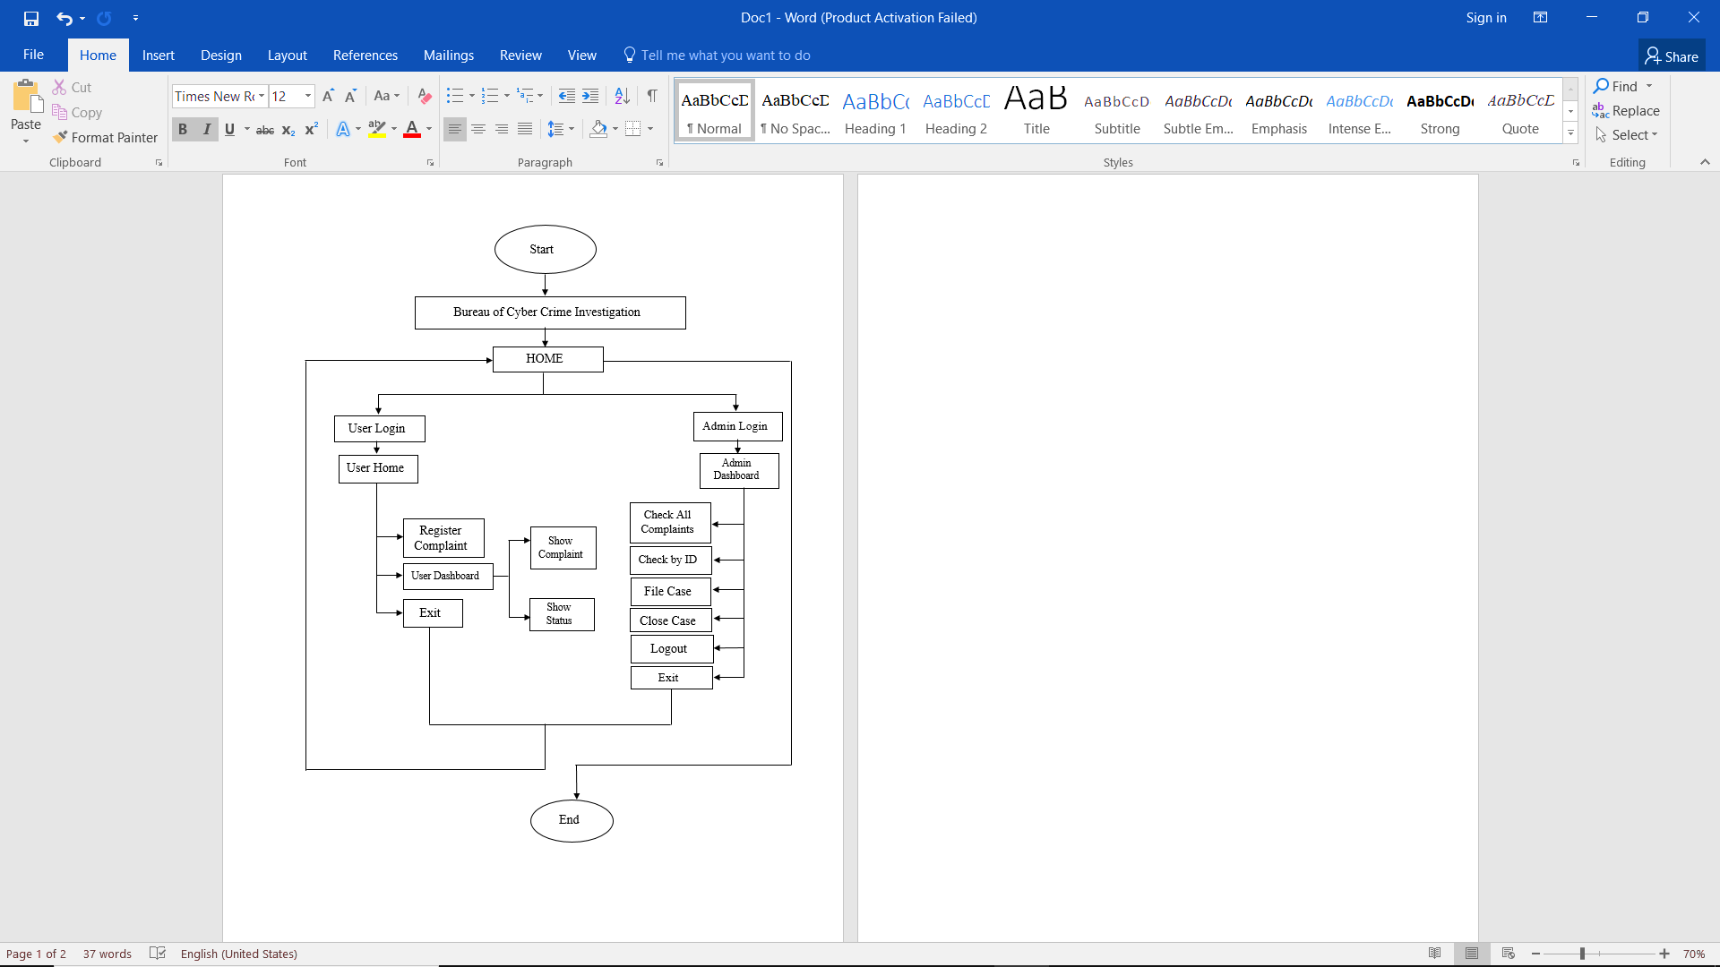This work contain various steps that two of module should follow. The data flow diagram of this work is illustrated in figure 5.1:

Figure 5.1: Dataflow diagram

**5.2.2 Database Design**

Database design is the organization of data according to a database model. The designer determines what data must be stored and how the data elements interrelate. With this information, one can begin to fit the data to the database model. Database management system manages the data accordingly.

There is a huge set of data to be used in each of the module of this work. Every data is important in its instance. The management of the data is done using MySQL dsatabse. Figure 5.2 shows the database schema diagram of this work.

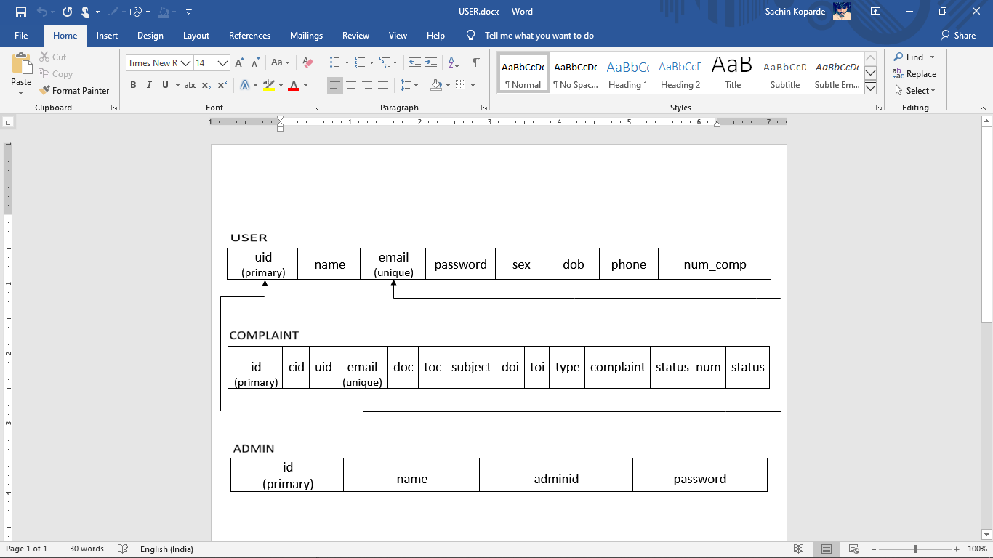

Figure 5.2: Database Design

**Chapter 6**

**Implementation**

I

mplementation is a process of development of an application. Once the system design is completed then actual development of system will starts. The development of application using system design is called the implementation phase. In this phase, largest system is divided into small modules. For each module, algorithms are developed and each algorithm is coded using programming languages. Implementation of proposed system is done as below.

**6.1 Implementation of User Registration Module**

**Index Page:**

<?php

$res=mysqli_query($con,"select * from message"); if(mysqli_num_rows($res)>0){ $html=''; while($row=mysqli_fetch_assoc($res)){

$message=$row['message'];

$added_on=$row['added_on'];

$strtotime=strtotime($added_on);

$time=date('h:i A',$strtotime);

$type=$row['type'];

if($type=='user'){ $class="messages-me";

$imgAvatar="user_avatar.png";

$name="You"; }else{ $class="messages-you";

$imgAvatar="bot_avatar.png";

$name="Chat Bot";

}

$html.='<li class="'.$class.' clearfix">

<span class="message-img">

<img src="image/'.$imgAvatar.'" class="avatar-sm rounded-circle">

</span>

<div class="message-body clearfix">

<div class="message-header">

<strong class="messages-title">'.$name.'</strong>

<small class="time-messages text-muted">

<span class="fas fa-time"></span>

<span class="minutes">'.$time.'</span>

</small> </div><p class="messages-p">'.$message.'</p>

</div>

</li>';

}

echo

$html;

}

Else

{

?>

<li class="messages-me clearfix start_chat"> Please start </li>

<

?php

}

?>

**CSS :**

body {

margin-top: 20px;

background-color: rgb(255, 0, 234);

}

.unread {

cursor: pointer;

background-color: #f4f4f4;

}

.messages-box {

max-height: 35rem;

overflow: auto;

/* background-color: #ECE5DD; */

}

.online-circle {

border-radius: 5rem;

width: 5rem;

height: 5rem;

}

.messages-title {

float: right;

margin: 0px 5px;

}

.message-img {

float: right;

margin: 0px 5px;

}

.message-header {

text-align: right;

width: 100%;

margin-bottom: 0.5rem;

}

.text-editor {

min-height: 18rem;

}

.messages-list li.messages-you .messages-title {

float: left;

}

.messages-list li.messages-you .message-img {

float: left;

}

.messages-list li.messages-you p {

float: left;

text-align: left;

background-color: #25D366;

}

.messages-list li.messages-you .message-header {

text-align: left;

}

.messages-list li p {

max-width: 60%;

padding: 5px;

border: #e6e7e9 1px solid;

}

.messages-list li.messages-me p {

float: right;

background-color: #DCF8C6;

}

.ql-editor p {

font-size: 1rem;

}

**6.2 Data Base Query**

CREATE TABLE `chatbot_hints` (

`id` int(11) NOT NULL,

`question` varchar(100) NOT NULL,

`reply` varchar(100) NOT NULL

) ENGINE=InnoDB DEFAULT CHARSET=latin1;

--

-- Dumping data for table `chatbot_hints`

--

INSERT INTO `chatbot_hints` (`id`, `question`, `reply`) VALUES

(1, 'HI||Hello||Hola', 'Hello, how are you.'),

(2, 'How are you', 'Good to see you again!'),

(3, 'what is your name||whats your name ||your name||Your name', 'My name is Vishal Bot'),

(4, 'what should I call you', 'You can call me Vishal Bot'),

(5, 'Where are your from', 'I m from India'),

(6, 'Bye||See you later||Have a Good Day', 'Sad to see you are going. Have a nice day');

-- --------------------------------------------------------

--

-- Table structure for table `message`

--

CREATE TABLE `message` (

`id` int(11) NOT NULL,

`message` text NOT NULL,

`added_on` datetime NOT NULL,

`type` varchar(10) NOT NULL

) ENGINE=InnoDB DEFAULT CHARSET=latin1;

--

-- Dumping data for table `message`

--

INSERT INTO `message` (`id`, `message`, `added_on`, `type`) VALUES

(1, 'Hi', '2020-04-22 12:41:04', 'user'),

(2, 'Hello, how are you.', '2020-04-22 12:41:05', 'bot'),

(3, 'what is your name', '2020-04-22 12:41:22', 'user'),

(4, 'My name is Vishal Bot', '2020-04-22 12:41:22', 'bot'),

(5, 'Where are your from', '2020-04-22 12:41:30', 'user'),

(6, 'I m from India', '2020-04-22 12:41:30', 'bot'),

(7, 'Go to hell', '2020-04-22 12:41:41', 'user'),

(8, 'Sorry not be able to understand you', '2020-04-22 12:41:41', 'bot'),

(9, 'bye', '2020-04-22 12:41:46', 'user'),

(10, 'Sad to see you are going. Have a nice day', '2020-04-22 12:41:46', 'bot');

--

-- Indexes for dumped tables

--

--

-- Indexes for table `chatbot_hints`

--

ALTER TABLE `chatbot_hints`

ADD PRIMARY KEY (`id`);

--

-- Indexes for table `message`

--

ALTER TABLE `message`

ADD PRIMARY KEY (`id`);

--

-- AUTO_INCREMENT for dumped tables

--

--

-- AUTO_INCREMENT for table `chatbot_hints`

--

ALTER TABLE `chatbot_hints`

MODIFY `id` int(11) NOT NULL AUTO_INCREMENT, AUTO_INCREMENT=7;

--

-- AUTO_INCREMENT for table `message`

--

ALTER TABLE `message`

MODIFY `id` int(11) NOT NULL AUTO_INCREMENT, AUTO_INCREMENT=11;

COMMIT;

/*!40101 SET CHARACTER_SET_CLIENT=@OLD_CHARACTER_SET_CLIENT */;

/*!40101 SET CHARACTER_SET_RESULTS=@OLD_CHARACTER_SET_RESULTS */;

/*!40101 SET COLLATION_CONNECTION=@OLD_COLLATION_CONNECTION */;

**6.3 Accessing Data from Database**

<?php

date_default_timezone_set('Asia/Kolkata');

include('database.inc.php');

$txt=mysqli_real_escape_string($con,$_POST['txt']);

$sql="select reply from chatbot_hints where question like '%$txt%'";

$res=mysqli_query($con,$sql);

if(mysqli_num_rows($res)>0){

$row=mysqli_fetch_assoc($res);

$html=$row['reply'];

}else{

$html="Sorry not be able to understand you";

}

$added_on=date('Y-m-d h:i:s');

mysqli_query($con,"insert into message(message,added_on,type) values('$txt','$added_on','user')");

$added_on=date('Y-m-d h:i:s');

mysqli_query($con,"insert into message(message,added_on,type) values('$html','$added_on','bot')");

echo $html;

?>

**Chapter 7**

**Testing**

T

he testing is a process of checking working of software and hardware products. Testing of software is called software testing and testing of hardware product is called hardware testing. Software testing is process of testing the software or application developed by the developers or programmers. Hardware testing is a process of testing the hardware products developed by hardware developers. Again, software and hardware testing include several different types of testing. Among these, most commonly used testing are unit testing and system testing. Once the implementation of system has been completed then the entire system is tested to check whether developed system satisfies the requirements specified by the users. The process of testing entire system is called system testing. On the other hand, system is developed by the integration of different modules. Testing of each module of a system is called the unit testing. Main purpose of the Testing is Software quality checking. In this work, unit tests are conducted on all modules and obtained the expected results. Later, system testing is conducted on entire system and obtained the expected results. Following table shows unit test cases and results of proposed approach.

**Table 7.1 Unit test cases for proposed approach**

|  |  |  |  |  |  |
| --- | --- | --- | --- | --- | --- |
| Test Case  Number | Input | Stage | Expected  Behavior | Observed Behavior | Status  P=Pass  F=Fail |
| 1 | Greeting | Communication  Staring | Information  Inserted into Table  Successfully | As expected | P |
| 2 | Replay from System | Output from System | Information  Fetched and Table Authenticated  Successfully | As expected | P |
| 3 | Asking Query | FAQ Registration | Information  Uploaded into  Table  Successfully | As expected | P |
| 4 | FAQ stored in Database | View Status | Information  Fetched from  Table  Successfully | As expected | P |
| 5 | Date and Time | View Status | Information  Fetched from  Table and Authenticated  Successfully | As expected | P |
| 6 | Matching Query with existing Data | Processing Query | Information  Fetched from  Table  Successfully | As expected | P |

**Chapter 8**

**Results**

Results basically refer to any particular output that comes as a result of the completion of the activities that have been performed as part of the project or a particular project component.

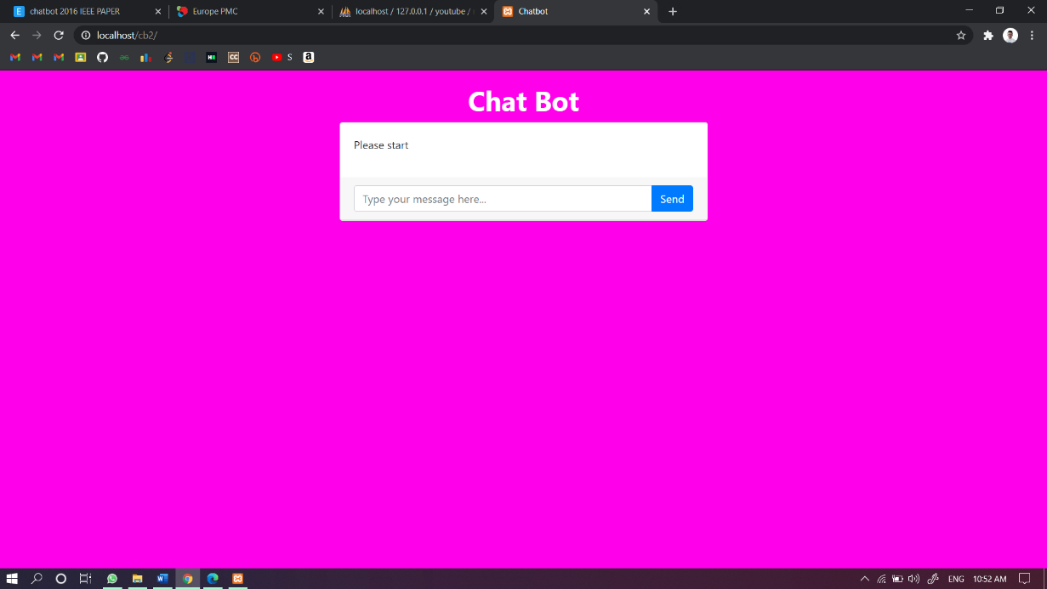The final snapshots of this work are as below:

Figure 8.1: Chat Bot Page

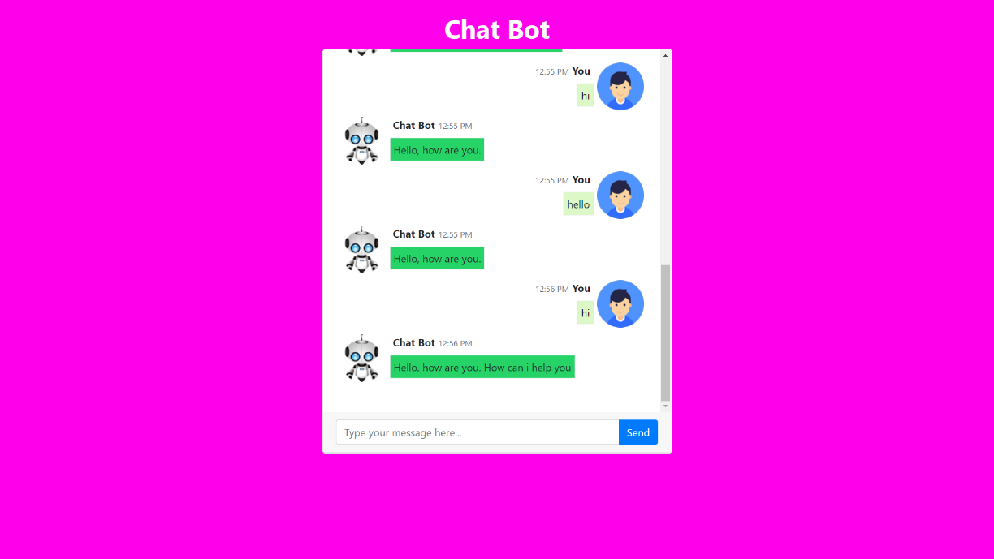Figure 8.1 shows the index page.

Figure 8.2: Conversation between user and Chat Bot

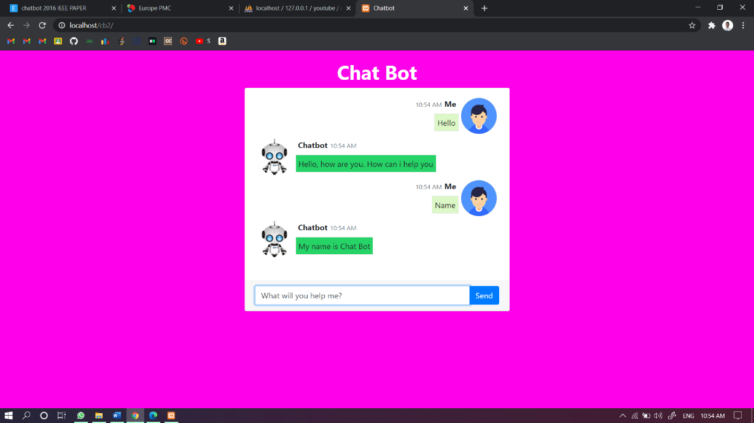When user starts to communicate with Chat Bot, Chat Bot replies to user immediately in this page shown in figure 8.2.

Figure 8.3: User Typing query in Text Box

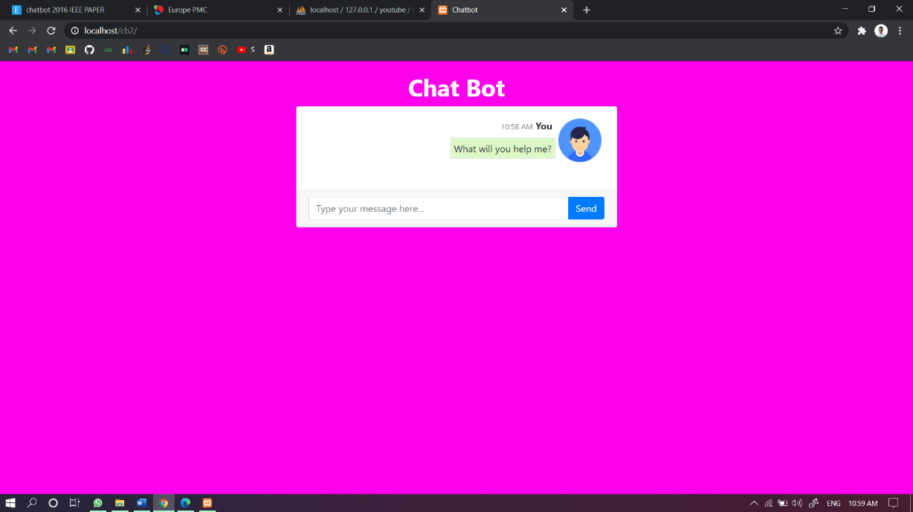There will be a text box provided to give input to the system in this page shown in figure 8.3.

Figure 8.4: Query from User

User asked FAQ’s to Chat Bot in this page shown in figure 8.4

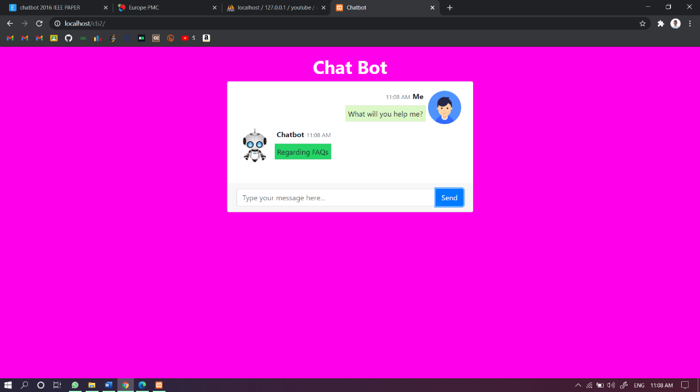

Figure 8.5: Replay from the Chat Bot

By taking the input from user Chat Bot processes and replayed to user to in this page shown in figure 8.5

**Chapter 9**

**Conclusions and Scope for Future Work**

T

his project is designed and developed as per the requirements of the FAQ in common websites. It can be a prototype of how a website can be designed and how functionalities can be implemented in complaint management system. The complete system is thoroughly tested with availability of data and through reports which are prepared manually. Design procedures and outputs are described in this project report. The design is easy to understand that any new modules can be incorporated easily. This work can be further improved using latest web technologies and tools. Enhancing the design and adding more features and functionalities it might be a good product.

**Bibliography**

1. Chatbot evaluation and database expansion via crowd sourcing, https://www.engpaper.com/chatbot-2016.htm/
2. Chatbot Using a Knowledge in Database: Human-to-Machine Conversation Modeling, https://ieeexplore.ieee.org/
3. Europe PMC, Europe PMC also contains Patents, NHS (National Health Service) guidelines, and Agricola records. https://europepmc.org/
4. Great Learning: Basics of building an Artificial Intelligence https://www.mygreatlearning.com/blog/basics-of-building-an-artificial-intelligence-chatbot/